Nama: Yusril Arzaqi

Kelas: TK-P.21.2

SINYAL 5

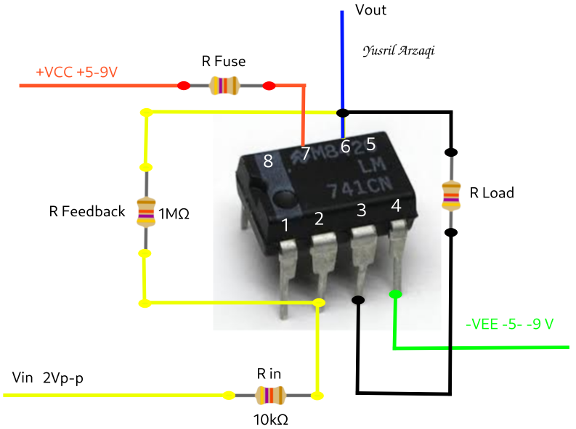

Vout = -(gain)xVin

= -100x2

= -200Vp-p